Pokhara University

Level: Bachelor | Semester – Fall | Year : 2009
Programme: BE |  | Full Marks : 100
Course: Engineering Mathematics II |  | Time : 3hrs.

Candidates are required to give their answers in their own words as far as practicable.
The figures in the margin indicate full marks.

Attempt all the questions.

1. | - Find the magnitude and equation of the shortest distance between the lines 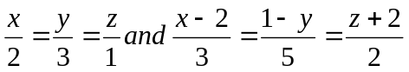  OR  Show that the lines 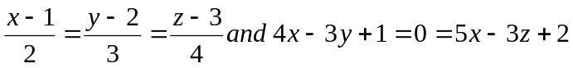 are coplanar. Also find their point of contact.  - Find the equation of the sphere through the circle x² + y² + z² = 1, 2x + 4y + 5z = 6 and touching the plane z = 0. | 8  7
2. | - State and prove Euler's theorem for a homogeneous function of two variable of degree n and hence if 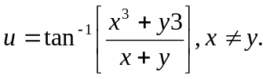show that 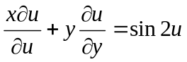.  - A rectangular box, open at the top, is to have a volume of 32 c.c. Find the dimension of the box requiring least material for its construction. | 8  7
3. | - Evaluate the integral by changing the order of integration: dy dx  - Find the volume of the solid whose base is the region in the xy- plane that is bounded by the parabola y = 4 - x² and the line y = 3x, while the top of the solid is bounded by the plane z = x + 4. | 7  8
4. | - Define order and degree of ordinary differential equation. Solve the initial value problem:  y’ + = x² , y(1) = 0.  - Find a general solution of y’’ - 4y’ + 3y = 10 e ^{-2x} | 8  7
5. | - Find a general solution of the equation by method of variation of parameter: y’’ - y’ + 4y =  - Solve y’’ = 8y by power series method.  OR  - What is Legendre's equation? Find its legendre's polynomials. | 8  7
6. | - Define Laplace transform. State and prove first shifting theorem of Laplace transform. Use it to evaluate 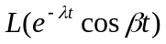  OR  Solve: 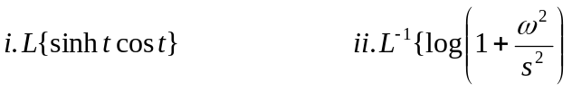  - Solve by using Laplace transform: | 8  7
7. | - Find Center and radius of a sphere x² + y² + z² + 4x - 6y + 8z = 10.  - Find integrating factor of ( xy³ + y) dx + 2( x² y² + x + y⁴) dy = 0.  - Find Laplace transform of f(t) = .  - If f(x,y,z) = + + , then show that x + y z = 0.  - Write down the criteria of maxima and minima of three independent variables | 5×2

